**Test Case 0006**

**System:** Bench

**Description:** Test that the user is blocked correctly and does not show up in the matching anymore.

**Severity:** 3

**Instructions**

**Test1**

1. Start the Bench application.
2. Click the button “Login” on the navigation bar.
3. Enter the email “team23project@gmail.com” into the text field labeled “Email address”.
4. Enter the password “12345678” into the field labeled “Password”.
5. Click the button “Login” below the field.
6. After the screen has loaded, click on the “View Profile” button of any of the three other user’s panels that the user would like to try to block.
7. Click on the button labeled “Block” on the selected user’s profile page.

**Expected Result:** An alert message should appear on the page, indicating that this user is blocked successfully.

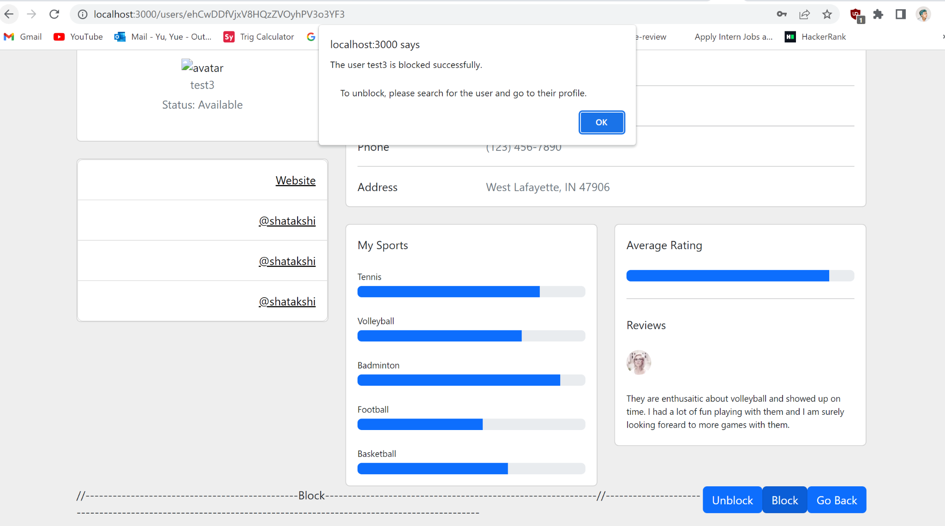

**Test2**

1. Start the Bench application.
2. Click the button “Login” on the navigation bar.
3. Enter the email “team23project@gmail.com” into the text field labeled “Email address”.
4. Enter the password “12345678” into the field labeled “Password”.
5. Click the button “Login” below the field.
6. After the screen has loaded, click on the “View Profile” button of any of the three other user’s panels that the user would like to try to block.
7. Remember the name of the user you are trying to block.
8. Click on the button labeled “Block” on the selected user’s profile page.
9. Click the button “OK” on the alert message.
10. Click the button “Go Back” to return to the “Explore” page.
11. Compare the names of the list of matched users shown on the page with, from memory, the name of the user you blocked.
12. The expected result is that the user’s name you blocked should not be part of the list of matched users shown anymore.
13. Click the button “Match Again” as many times as you want.
14. Keep comparing the names of the list of matched users shown on the page with, from memory, the name of the user you blocked.

**Expected Result:** the user’s name you blocked should not be part of the list of matched users shown anymore.

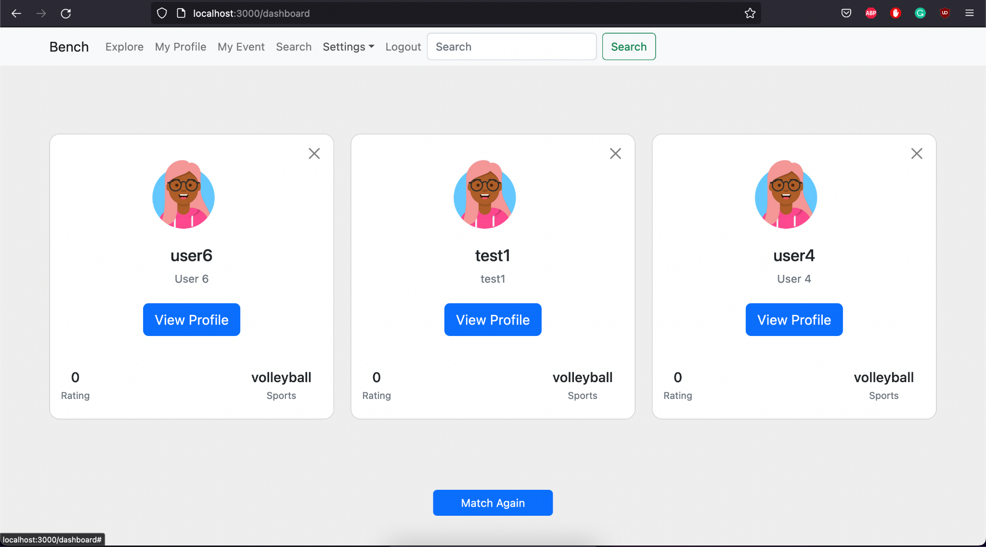

**Test 3**

1. Start the Bench application.
2. Click the button “Login” on the navigation bar.
3. Enter the email “team23project@gmail.com” into the text field labeled “Email address”.
4. Enter the password “12345678” into the field labeled “Password”.
5. Click the button “Login” below the field.
6. After the screen has loaded, click on the “View Profile” button of any of the three other user’s panels that the user would like to try to block.
7. Remember the username of the user you are trying to block.
8. Click on the button labeled “Block” on the selected user’s profile page.
9. Click the button “OK” on the alert message.
10. Click the button “Go Back” to return to the “Explore” page.
11. Click the button “Search” on the navigation bar.
12. Click the radio labeled “username” below the search bar.
13. Enter the username of the user you blocked from memory into the search bar.
14. Click the button “Search”.
15. Click the button “View Profile” when the related user’s profile panel appears.
16. Click the button “Unblock” on the related user’s profile page.
17. Click the button “OK” on the alert message.
18. Click the button “Explore” on the navigation bar.
19. Compare the names of the list of matched users shown on the “Explore” page with, from memory, the name of the user you blocked.
20. Click the button “Match Again” as many times as you want.

**Expected Result:** the user’s name you unblocked should again be part of the list of matched users shown.

